**Kartzon-Excel Project**

**Task 1**

1. **Create another column before the Segment Column named as "Customer's First Name"?**

**Ans.**

**Step 1-** Right Click the “Segment” Column and click on Insert. This will insert a blank column on the left of Segment column. Name the newly created column as “Customer’s First name”.

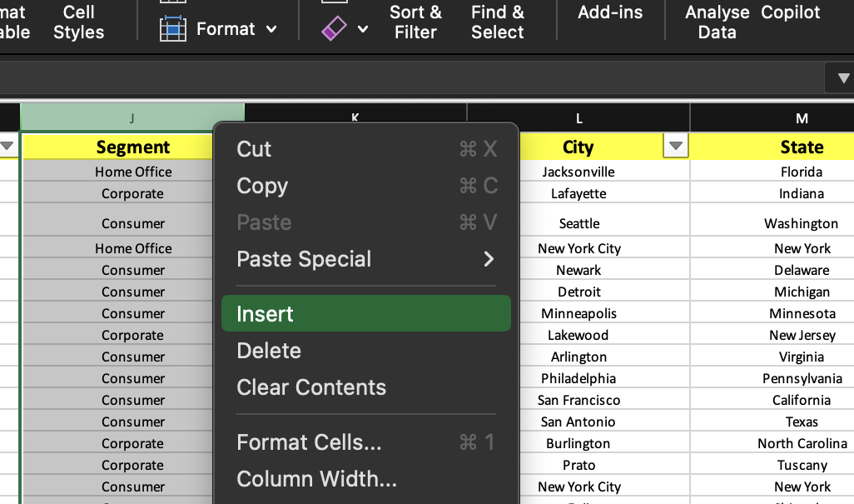

**Step 2-** Now, use the following function in the formula bar for Customer’s First Name column:

=LEFT(H2, SEARCH(“ “,H2)-1)

, where H is the Customer’s Name column. Here, the SEARCH() function will return the index of

the space between the First and Last Name in H2. The LEFT() function will return the value in H2

to the left of the index as specified by the second argument to this function.

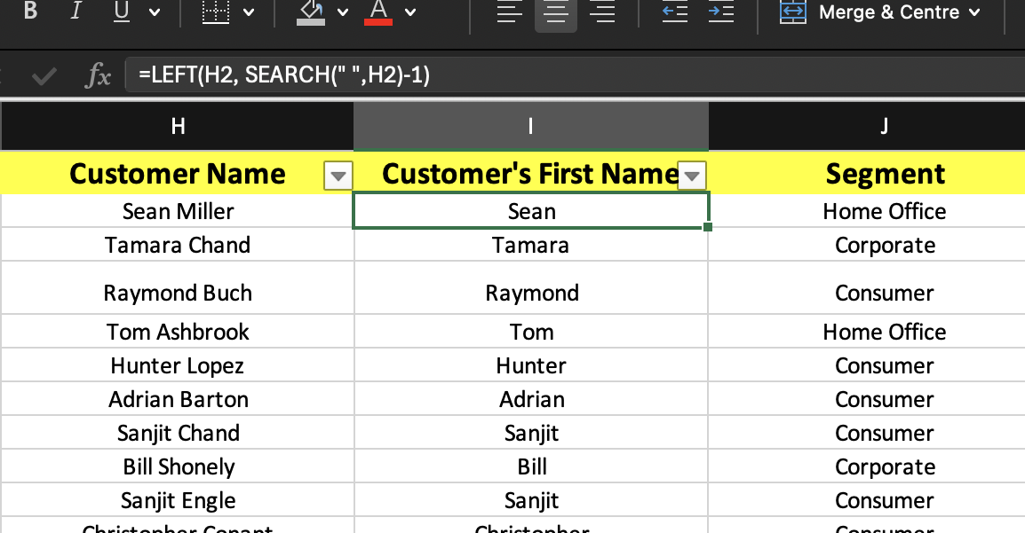

1. **Make use of cell reference and create a new column again for row id**

**Ans. Step 1-** First create a new column and name it as “Row ID(ref.)”.

**Step 2-** Write in the formula bar :

=B2

, where B is the Row ID Column.

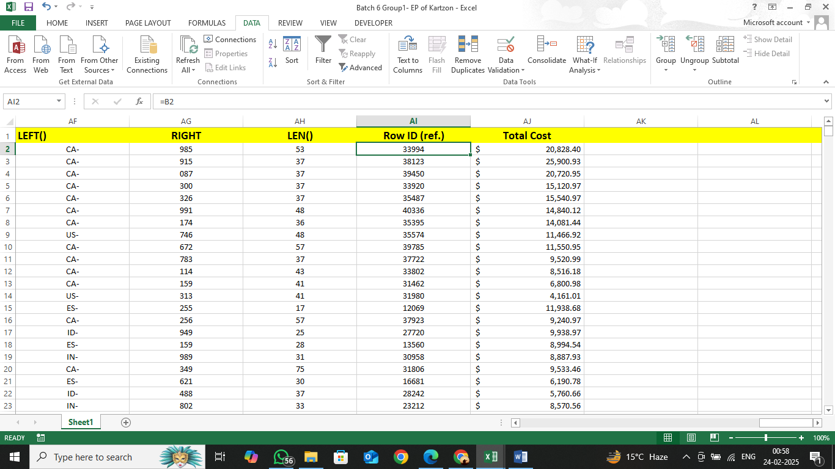

1. **Format the heading(1st row) Size-14, Bold, Background color light yellow**

**Ans.** Do the following steps:

* Double click the row header 1 to select the 1st row.
* Under the Home tab, and the font section, choose font size as 14
* Click on the Bold Button to make the text bold.
* Click on the background colour button and choose yellow.

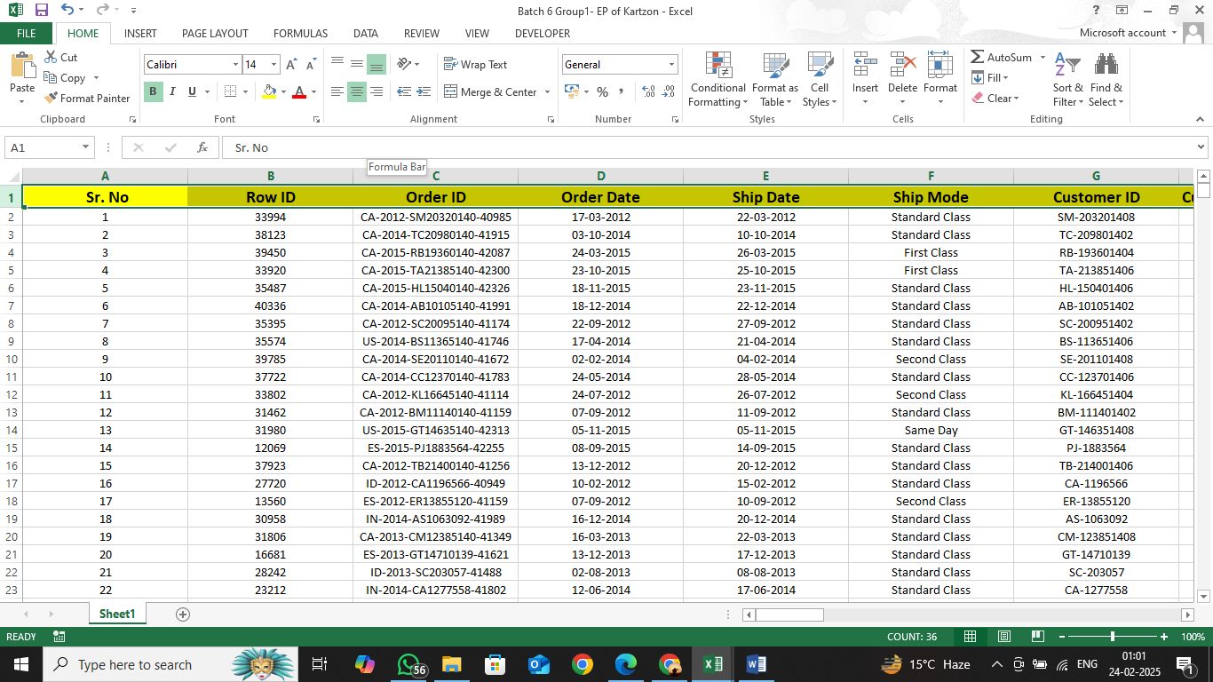

1. **Bring all numerical figures in Dollars $ as prefix- Sales, profit, Shipping cost in (currency form)**

**Ans.** First, select the column. Go to Number group in the “Home Tab”, then click on currency, and then $.

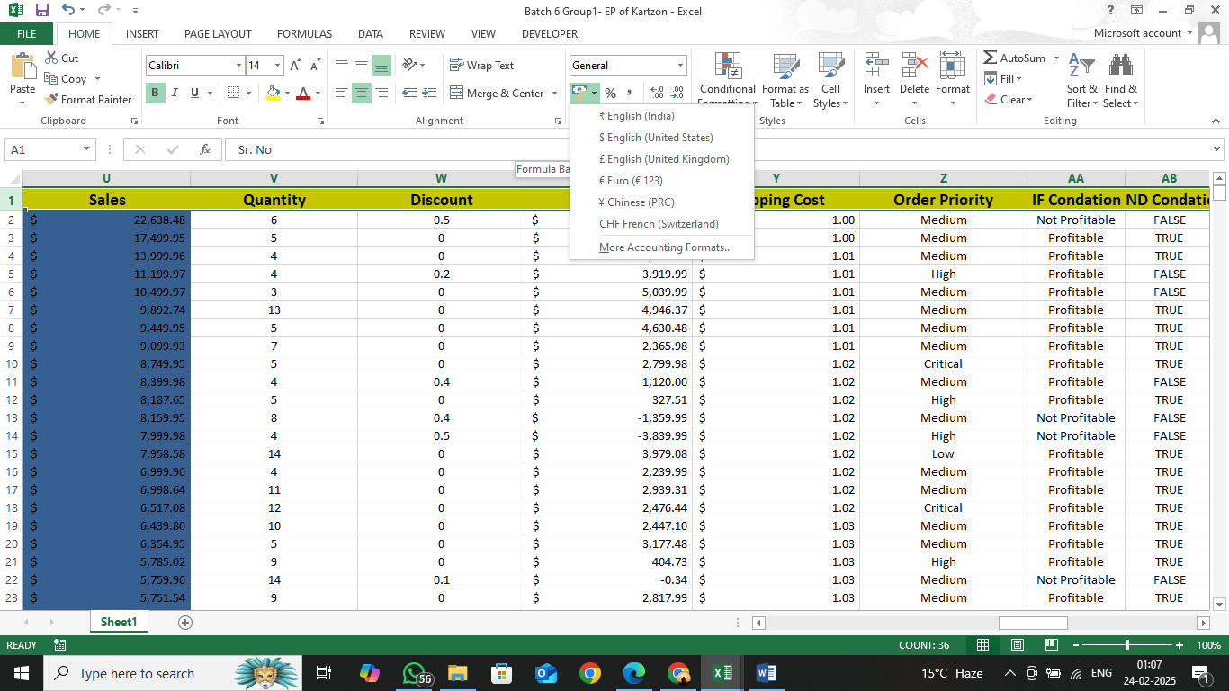

1. **Add filter to 1st Row only**

**Ans**. First, select the heading row then Go to the Editing group in the “Home Tab”. Click on the Sort&Filter, and choose filter.

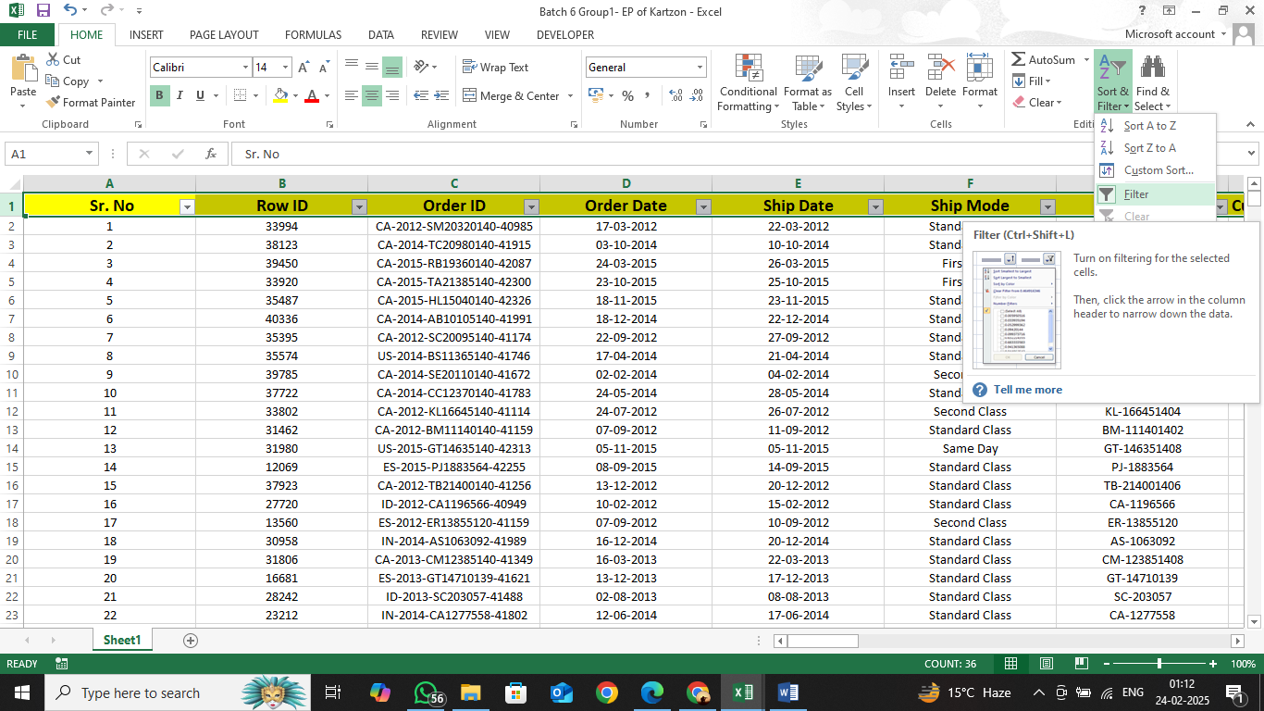

1. **Sort the value of shipping cost in ascending order**

**Ans.** Select the shipping cost then go to “Home Tab” then click on Sort&Filter then click on “Sort A to Z”.

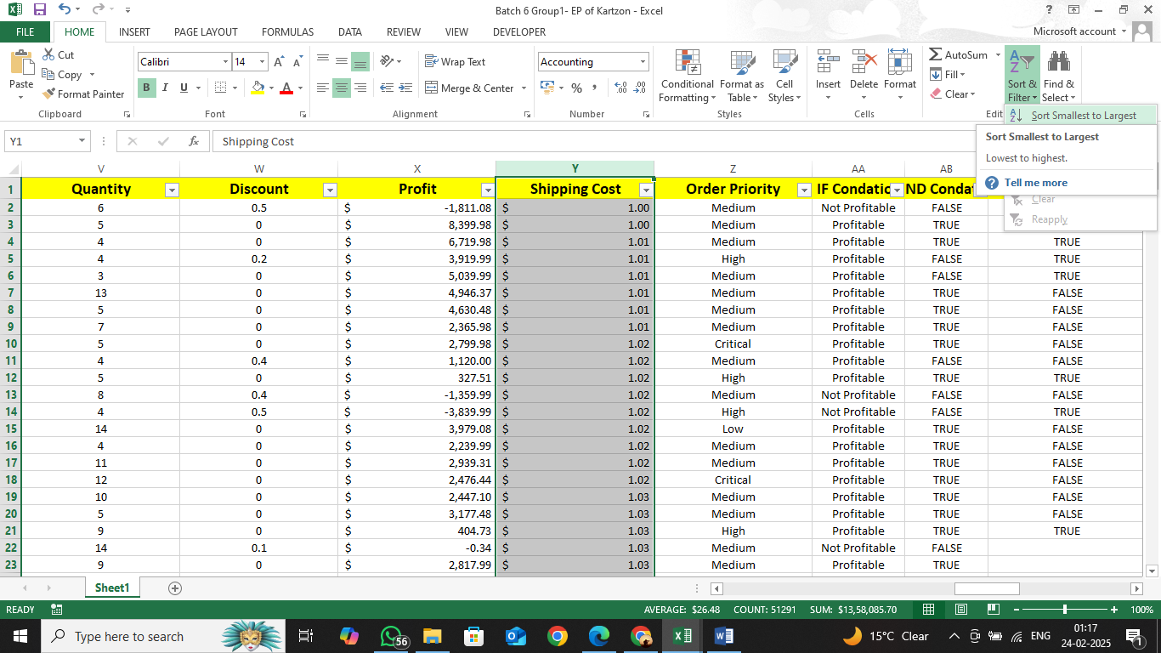

1. **Add Sr. No column at first**

**Ans.** To add serial number column, right click on the Row ID column and click Insert. This will insert

a new column on the left.

Name the column as SR. No.

Use the following function in the formula bar:

=ROW()-1

The ROW() function returns the row number of the current cell.

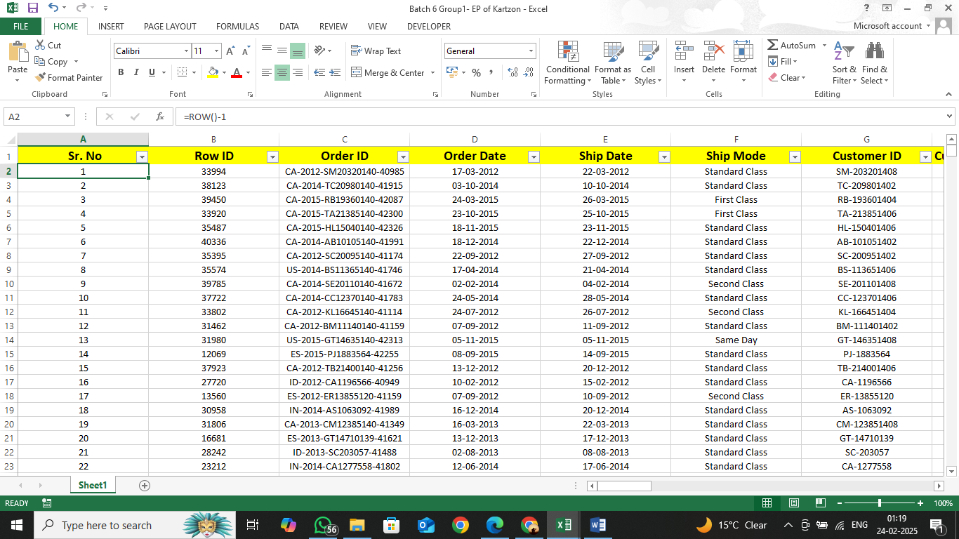

1. **Apply conditional formatting in Sales Above 500- light blue Below 500- light red**

**Ans**. First, select the Sale column then go to “Home Tab” then click on Conditional Formatting then select formatting based on condition.

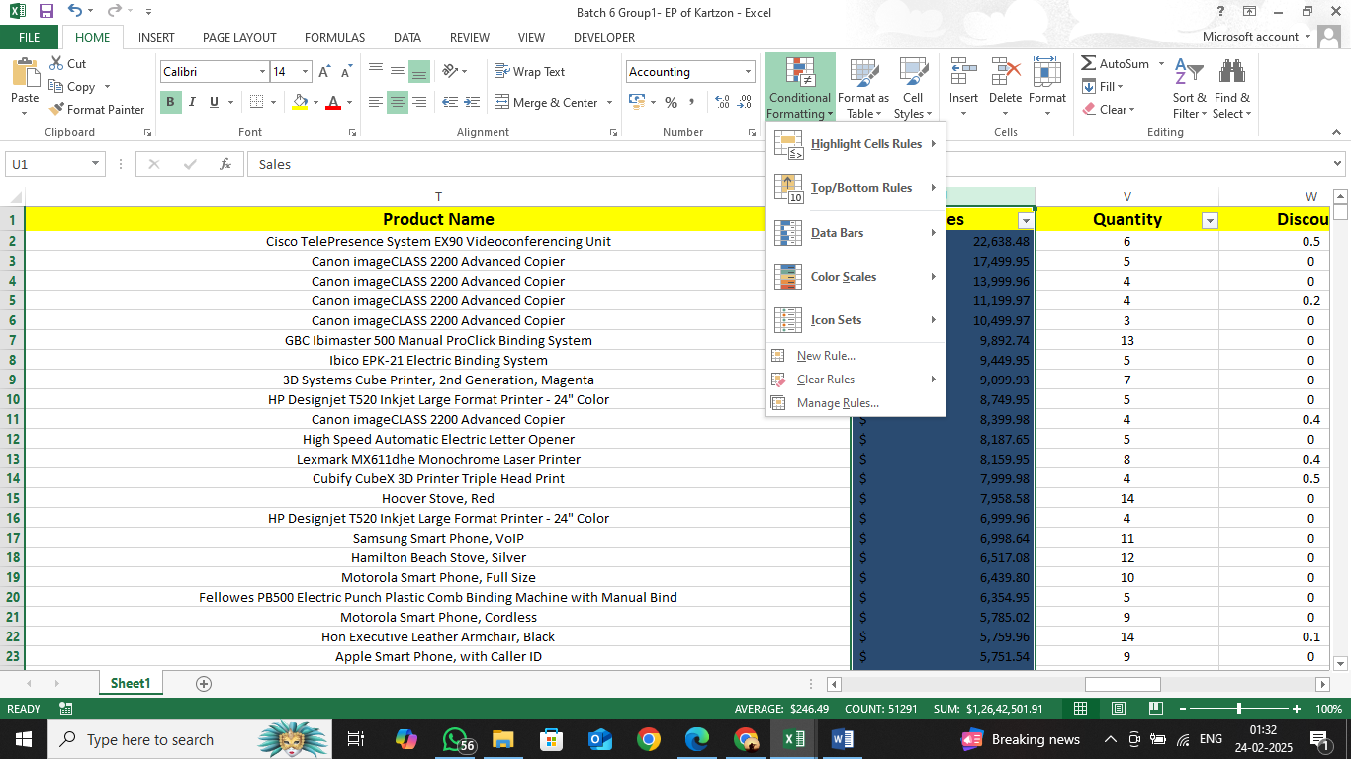

1. **Find the Total Cost Using Sales, Profit, Shipping cost**

**Ans.**

**Step 1-** Create a new column then name it Total cost.

**Step 2**- Use the sum function to calculate total cost which includes sales, profit, and shipping cost.

Type this in the formula bar:

=SUM(U2-X2+Y2)

, where U is the Sales column, X is the Profit Column, and Y is the Shipping cost column.

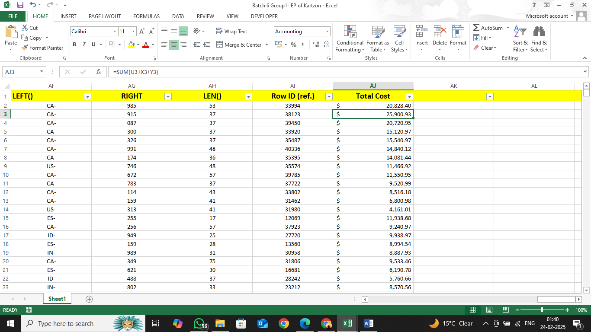

**Task 2(Basic Arithmetic)**

1. **Use =SUM() to calculate the total Sales for all orders.**

**Ans.**

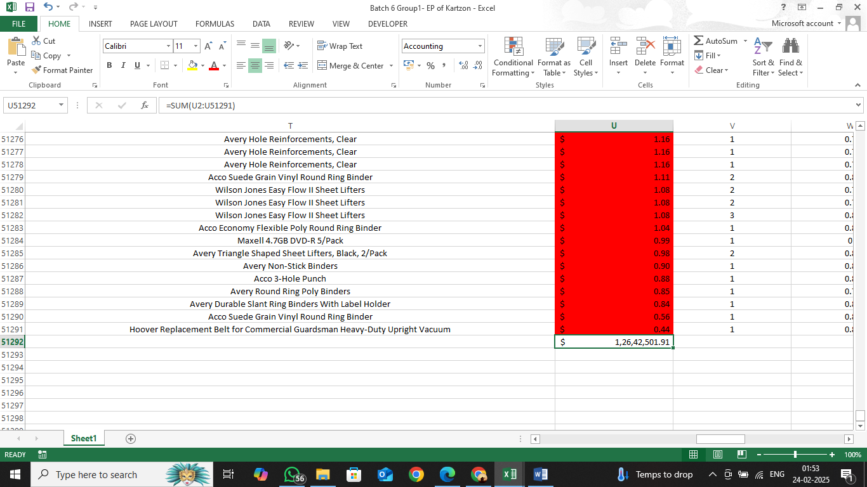

1. **Use =AVERAGE() to find the average Profit per order.**

**Ans.**

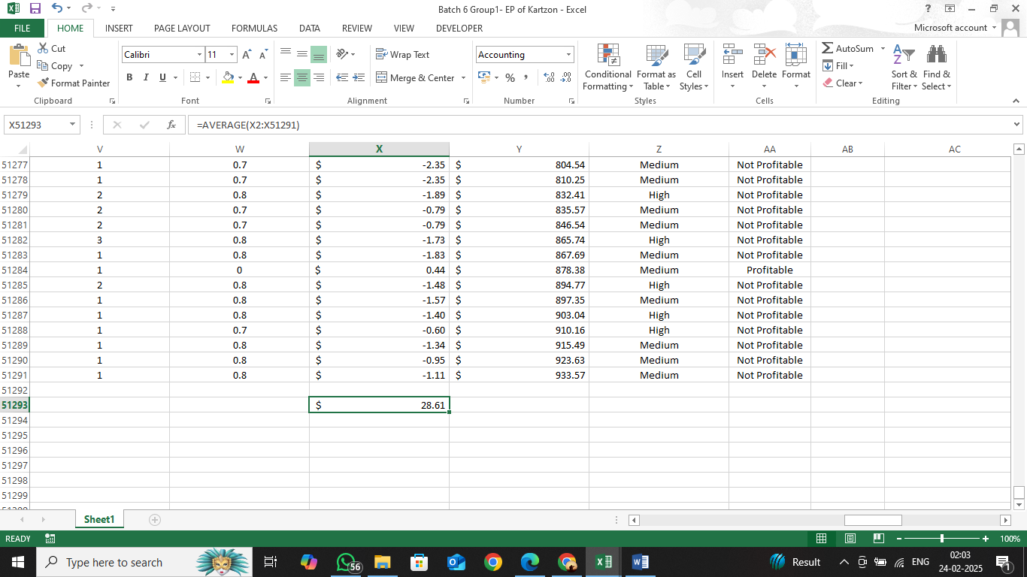

1. **Use =MIN() and =MAX() to determine the lowest and highest Shipping Cost. Logical Functions:**

**Ans.**

**MIN()**

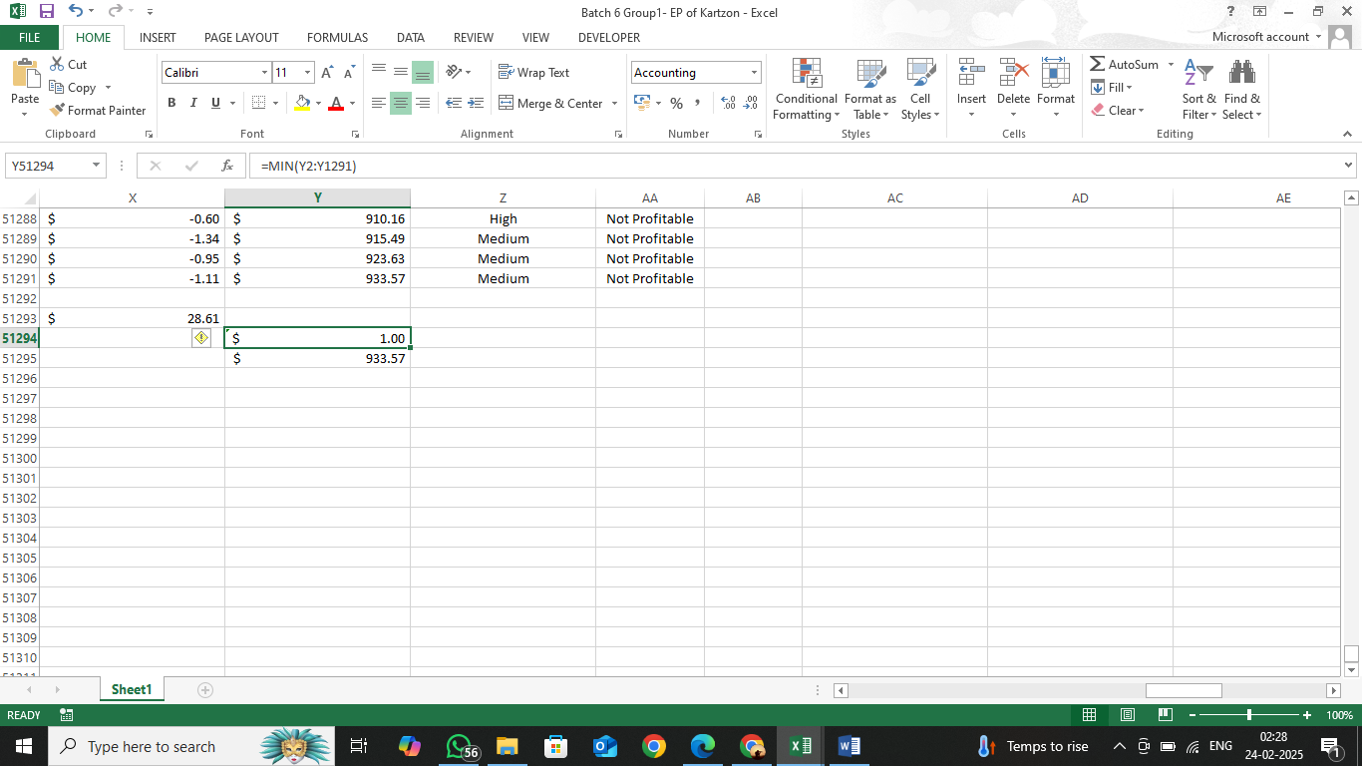

**MAX()**

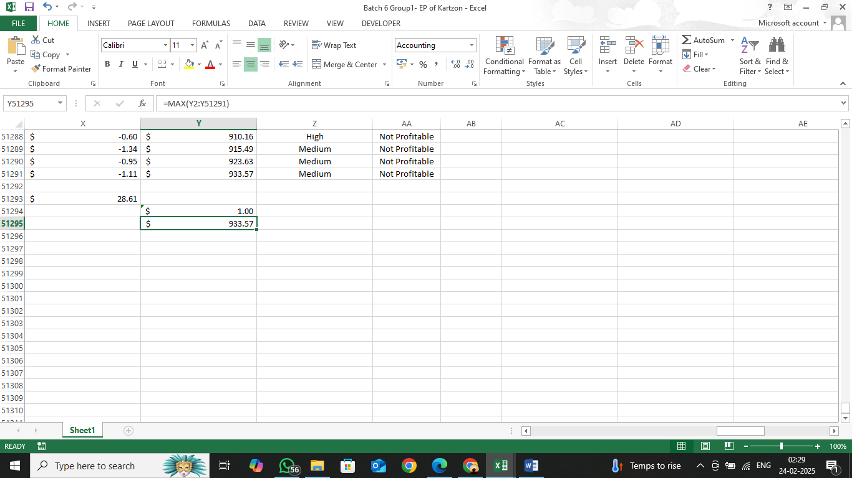

1. **Use =IF() to check if the Profit for an order is positive, and label it "Profitable" or "Not Profitable."**

**Ans.** Use the following function in the formula bar:

=IF(X2:X51291>0,”Profitable”,”Not Profitable”)

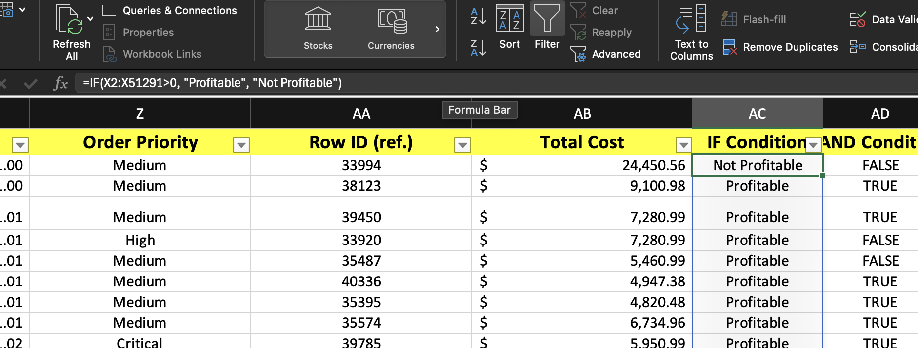

1. **Use =AND() to identify orders where both Discount is 0 and Quantity is greater than 3**

**Ans.** Use the following function in the formula bar:

=AND(V2,W2>3)

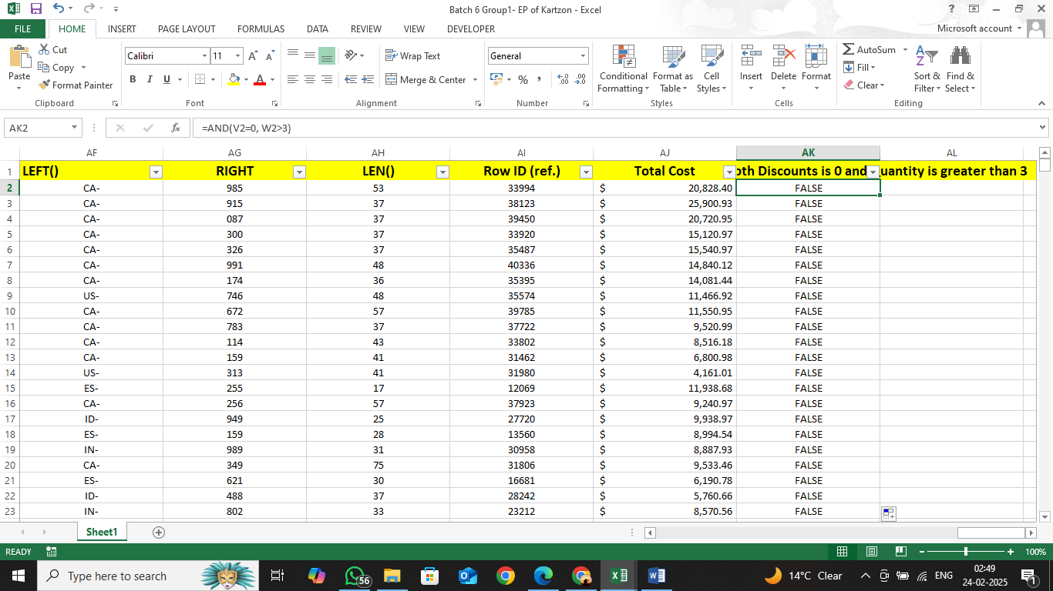

1. **Use =OR() to flag orders with either a "High" Order Priority or Sales over 10,000.**

**Ans.** Use the following function in the formula bar :

=OR(Z2=”High”,U2>10000)

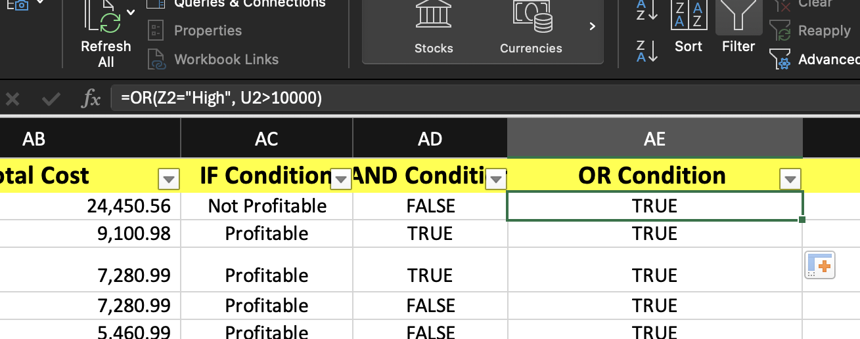

1. **Use =NOT() to find orders that are not in the "Consumer" Segment. Text Functions:**

**Ans.** Use the following function in the formula bar to find orders where SEGMENT is not Consumer :

=NOT(J2=”Consumer”)

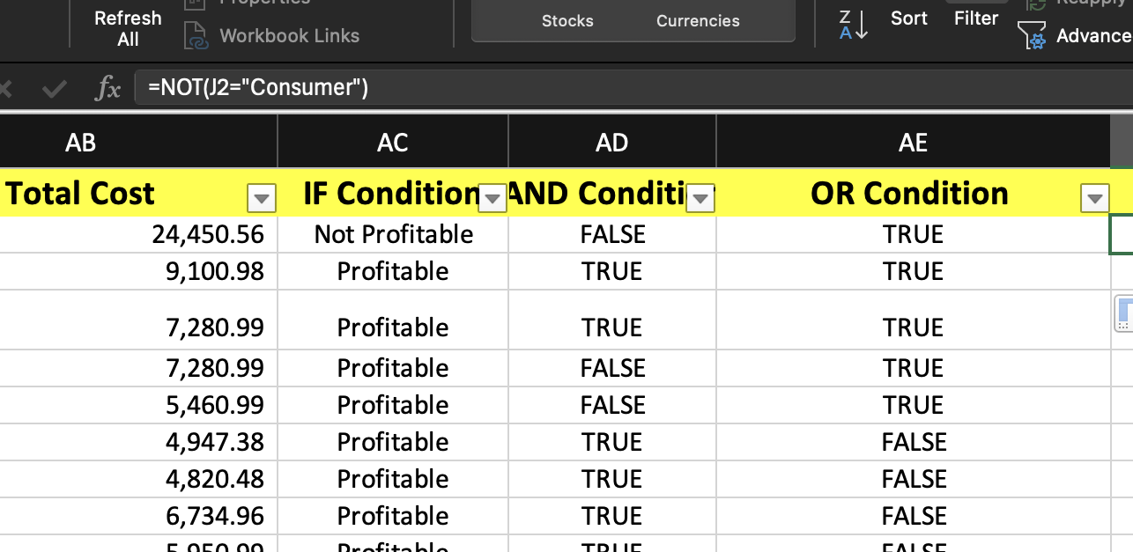

**8) Use =CONCAT() to combine Customer Name and City into a single cell.**

**Ans.** Use the following function in the formula bar:

=CONCAT(“H2”,”,”,”L2”)

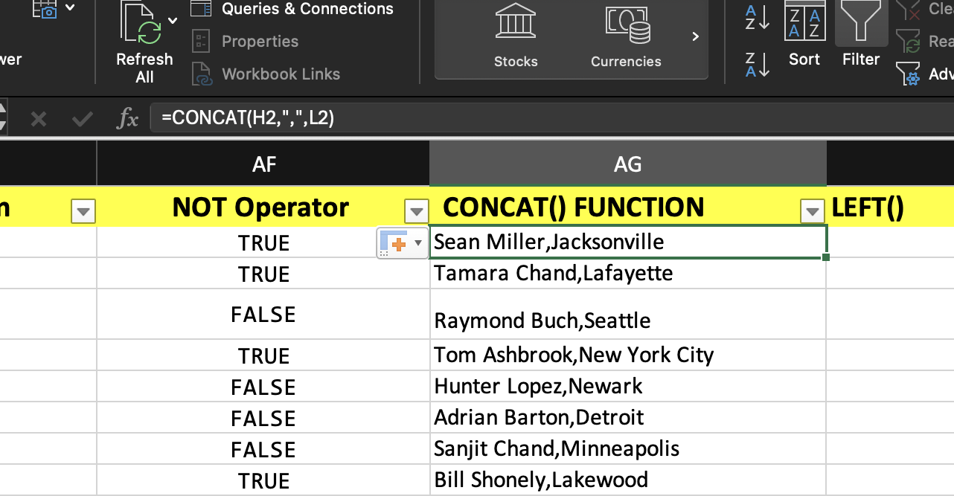

**9)**  **Use =LEFT() to extract the first three characters of the Order ID**

**Ans.** Use the following function in the formula bar.

=LEFT(C2,3)

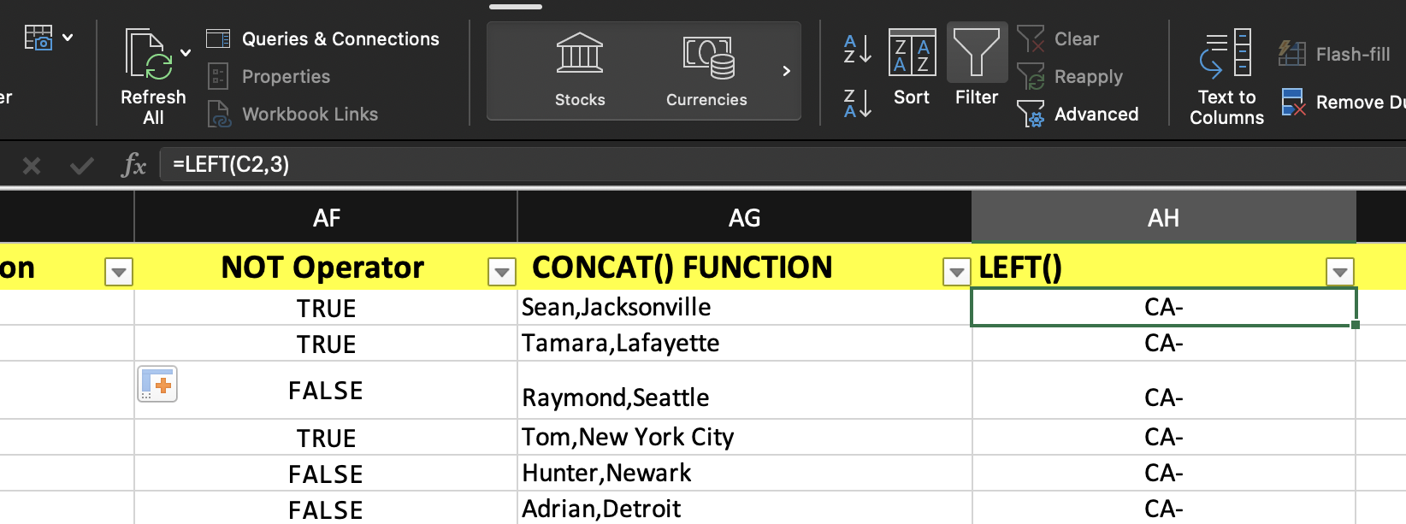

**10)**  **Use =RIGHT() to extract the last three digits of the Customer ID.**

**Ans.** Use the following function in the formula bar:

=RIGHT(C2,3)

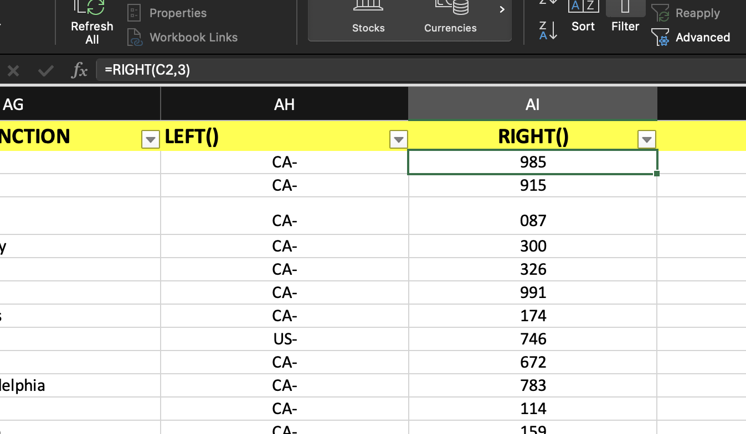

**11) Use =LEN() to count the number of characters in Product Name.**

**Ans.** Use the following function in the formula bar:

=LEN(T2)

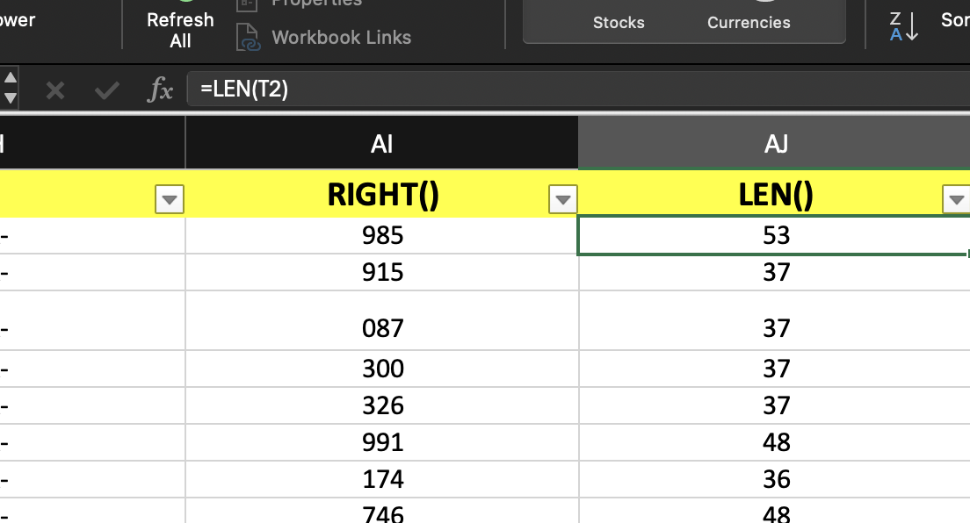

**12) Use =VLOOKUP() to find the Category based on a given Product ID.**

**Ans.** Use the function in the formula bar:

=VLOOKUP(Q2,Q2:Z51291,2,FALSE)

, where Q is the Product ID column, 2 is the column index/number from the table array specified as the second argument in the vlookup() function. FALSE is to get the exact match.

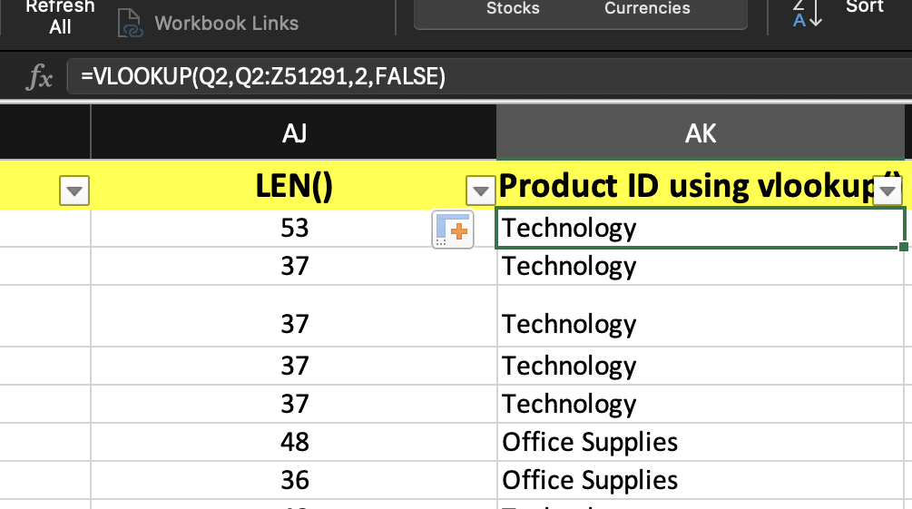

Use this to get the category for a specific Product ID:

=VLOOKUP(AX7,Q2:Z51291,2,FALSE)

,where AX7 has the specific product id.

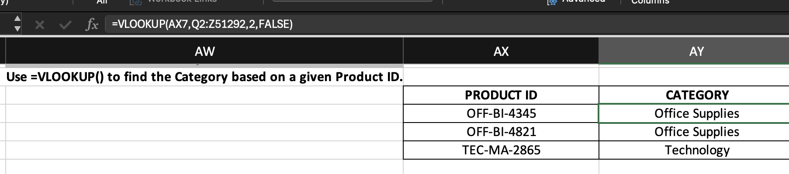

**13) Use =HLOOKUP() to fetch the Sales value from a row header for a specific order.**

**Ans.** **METHOD1 (TRANSPOSES THE TABLE):**

Use the function in the formula bar :

=HLOOKUP(C2,TRANSPOSE(C2:X51291),19,FALSE)

, where C is the Order ID row, 19 is the row number from which the Sales value will be returned and

TRANSPOSE(C2,Z51291) is the transposed table.

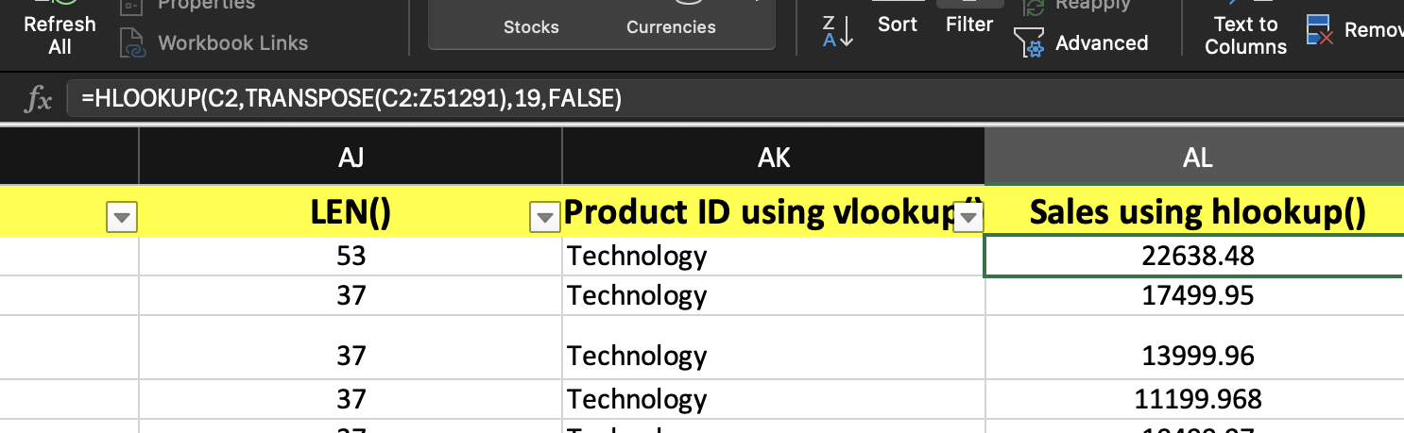

**Sales for a specific Order ID:**

=HLOOKUP(AX15,TRANSPOSE(C2:X51291),19,FALSE)

, where AX15 contains the Order ID.

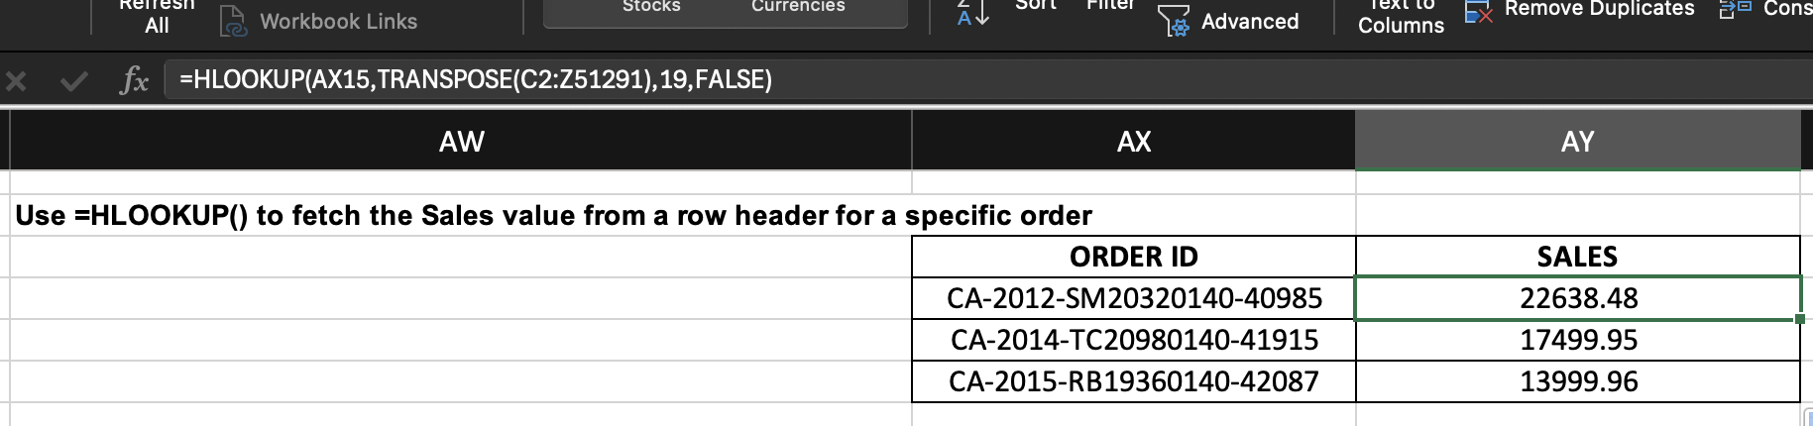

**METHOD 2( Uses MATCH() function to find the position/row number of a specific Order ID)**

Use the following function in the formula bar :

=HLOOKUP("Sales",A1:Z51291,MATCH(BA15,C:C,0),FALSE)

, where BA15 has the specific Order ID.

MATCH() function finds the position/ row number of the Order id at BA15 in the column C (Order ID column).

HLOOKUP() searches for the Sales column in the first row and returns the corresponding sales value from the

row provided by the match function.

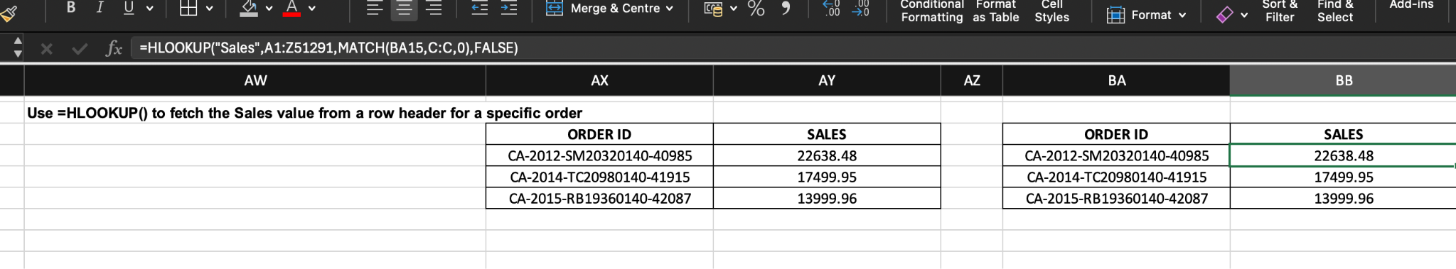

**14) Use =INDEX() and =MATCH() together to find the Profit for a specific Order ID.**

**Ans.** Use the function in the formula bar :

=INDEX(X2:X51291,MATCH(C2,C2:C51291))

, where C is the Order ID column and X is the Profit column.

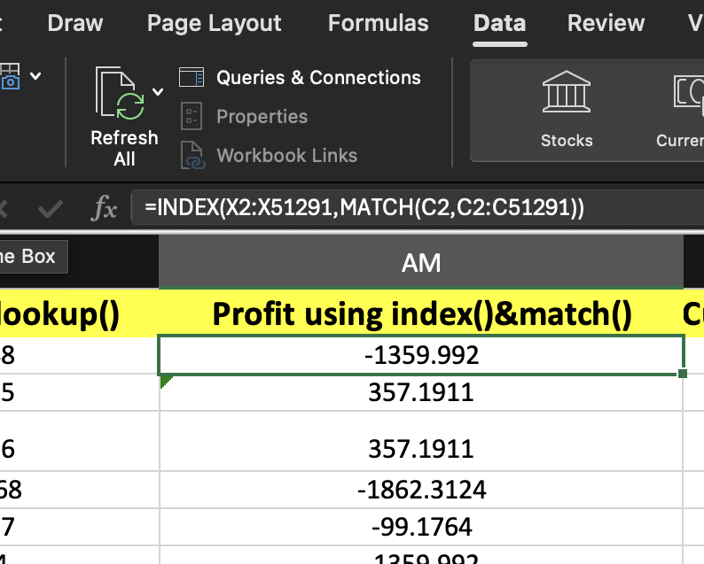

For a specific Order ID:

=INDEX(X2:X51291,MATCH(AX23,C2:C51291))

, where AX23 has the specific Order ID.

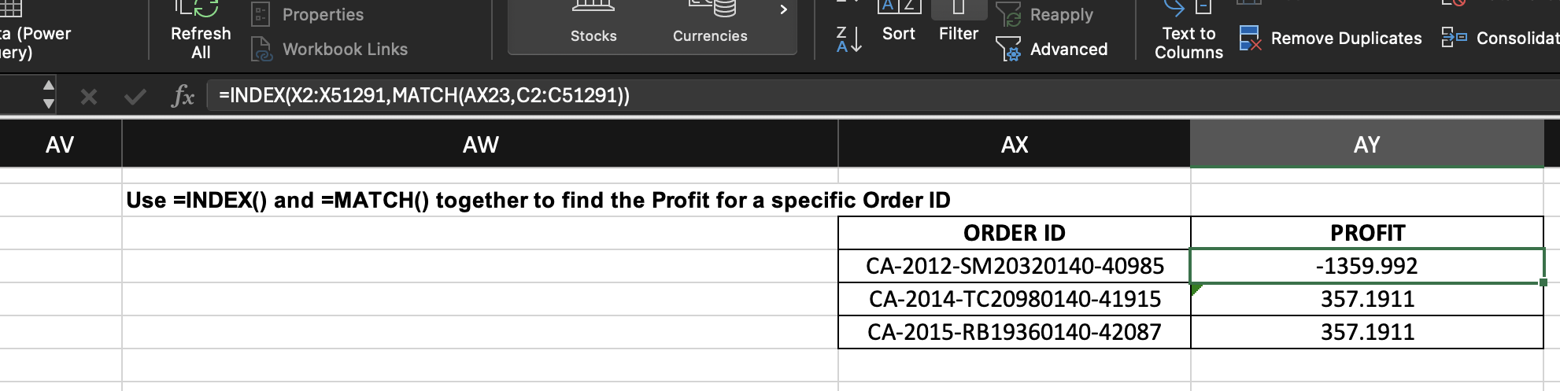

**15) Use =XLOOKUP() to search for a Customer Name by their Customer ID.**

**Ans.** Use the function shown in the formula bar in the following image:

=XLOOKUP(G2,G2:G51291,H2:H51291)

, where G is the Customer ID column, and H is the Customer Name column.

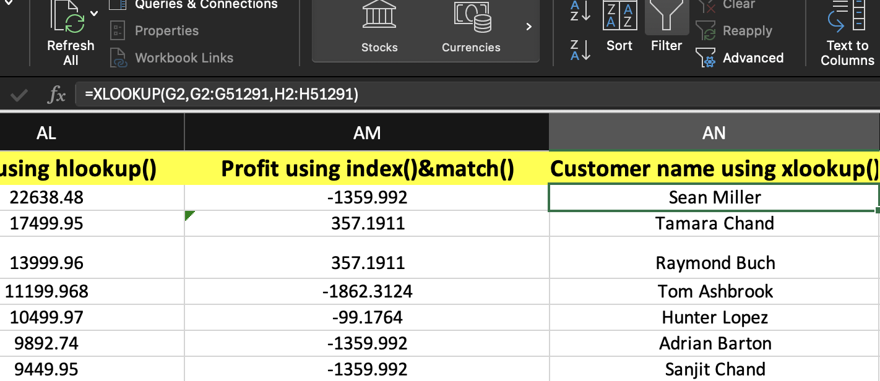

For a specific Customer ID:

=XLOOKUP(AX31,G2:G51291,H2:H51291)

, where AX31 has the specific Customer ID.

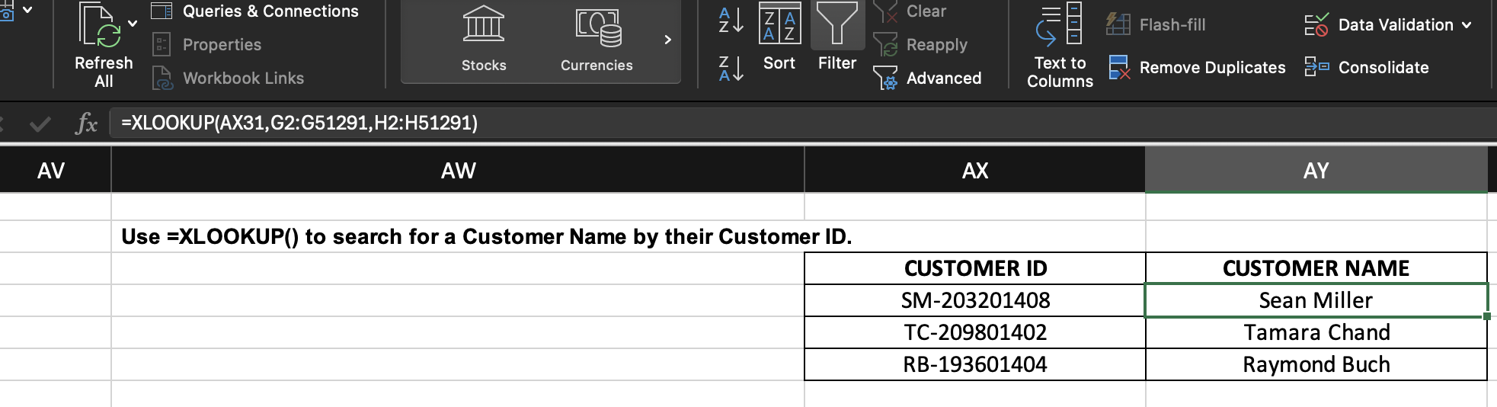

**16) Use =TODAY() to determine how many days have passed since the Order Date for each order.**

**Ans.** Use the following function in the formula bar:

=TODAY() - D2

, where D is the Order Date Column.

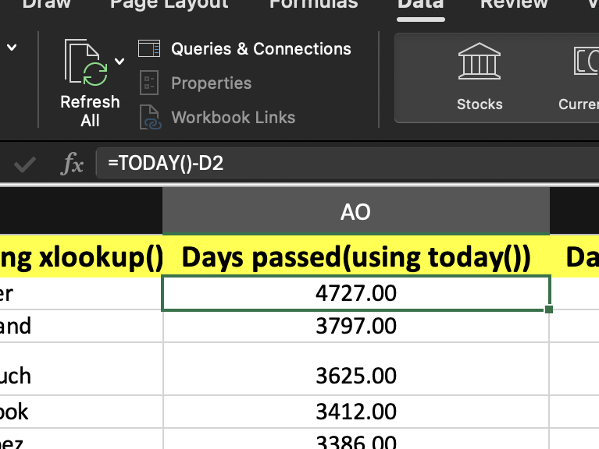

**17) Use =DATEDIF() to calculate the number of days between the Order Date and Shipping date.**

**Ans.** Use the following function in the formula bar:

=DATEDIF(D2,E2,”D”)

, where D is the Order Date Column, E is the Shipping Date Column and the third argument, “D”, is to get the output in days.

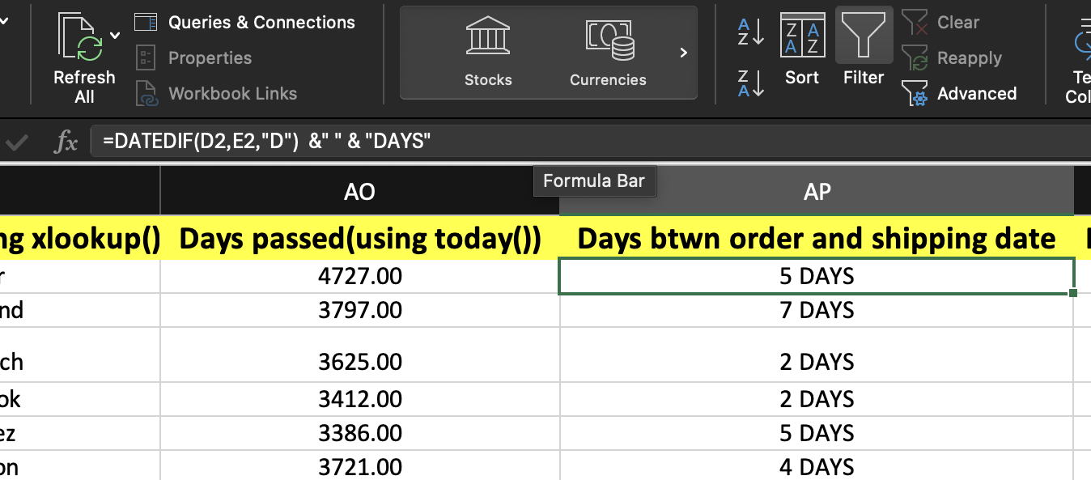

**18) Use =TEXT() to display the Order Date in "MMM-DD-YYYY" format.**

**Ans.** Use the following function in the formula bar:

=TEXT(D2, “MMM-DD-YYYY”)

, where D is the Order Date Column and the second argument in the function specifies the format we want the order date in.

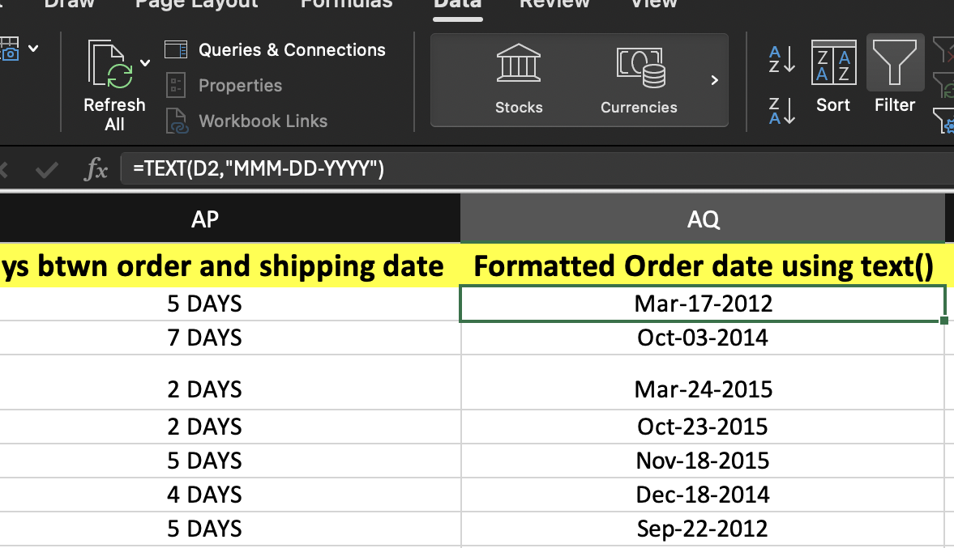

**19) Use =IFERROR() to handle errors when dividing Profit by Quantity.**

**Ans.** Use the following function in the formula bar:

=IFERROR(IF((V2="")+(V2<0),"ERROR: Quantity is negative/empty value",ABS(X2)/V2),"ERROR: Invalid Quantity")

, where X is the Profit column, Y is the quantity column and ABS() is a function used to get the absolute value of the input.

This returns ABS(X)/V if there is no error, returns “Error: Quantity is negative/empty value” if V(quantity) is either negative or empty. For all other errors, this returns “Error:Invalid Quantity”.

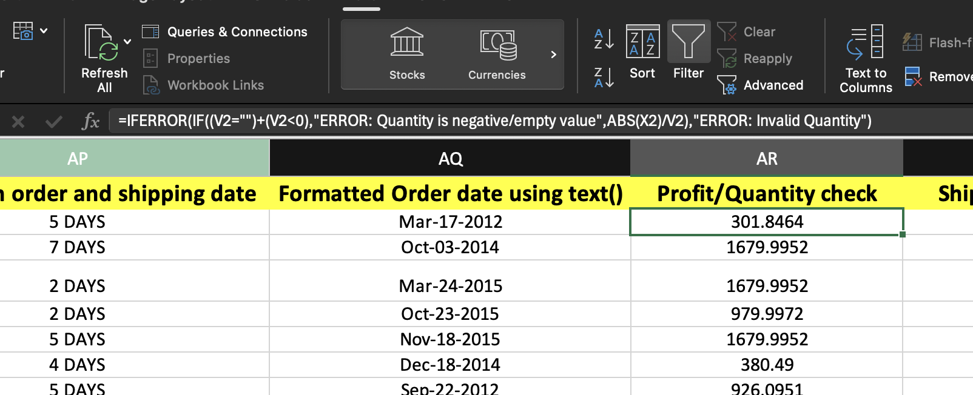

You can also use a formula as simple as this one : =IFERROR(ABS(X2/V2),”Invalid Quantity”).

**20) Use =ISERROR() to check for invalid data in the Shipping Cost column.**

**Ans**.Use the following function in the formula bar:

=IFERROR(IF(Y2="","ERROR:Invalid Shipping Cost",IF(Y2<0,"ERROR: Negative Shipping Cost",Y2)),"ERROR:Invalid shipping cost")

, where Y is the shipping cost column.

This checks for a few different cases of invalid shipping cost using the IF() function. It returns “ERROR: Negative Shipping Cost” if the Shipping cost is negative and returns an Invalid shipping cost Error if the shipping cost cell is empty or contains other invalid value. Returns the Shipping cost if no error is found.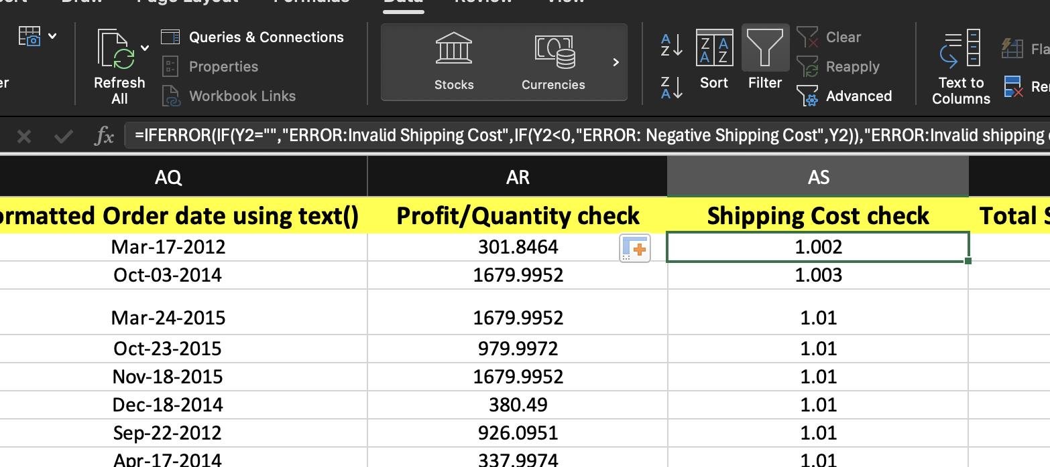

**21) Use =ARRAYFORMULA() to compute total Sales for each Category in one go.**

**Ans.** Use the following function in the formula bar to get the corresponding Total Sales for each row according to its Category:

=SUMIFS(U2:U51291,R2:R51291,R2)

, where U is the Sales column, and R is the Category column.

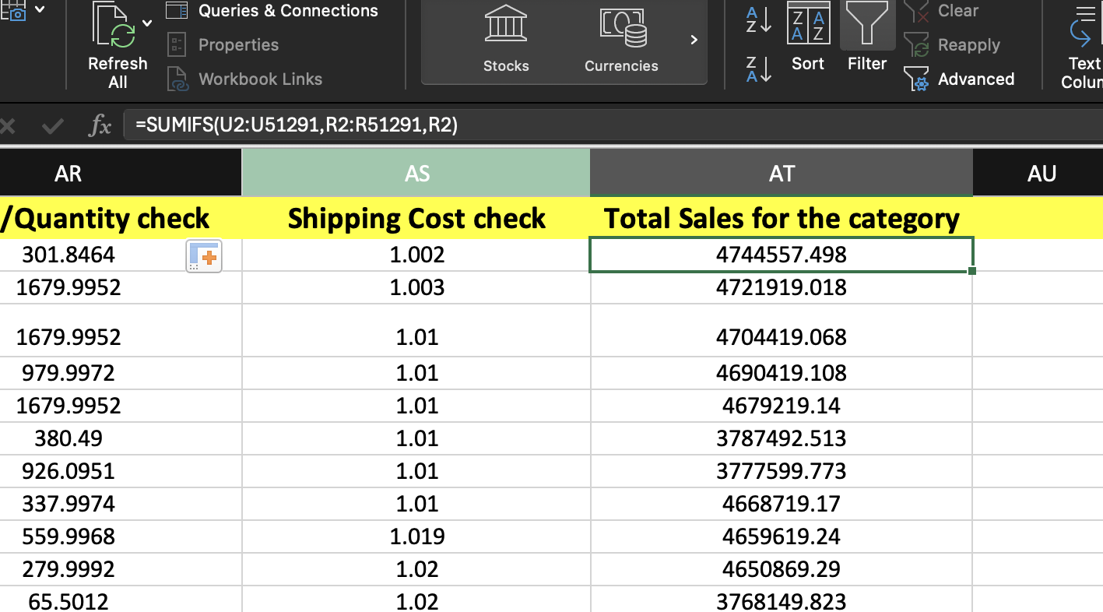

**To find the sales for each category, we can use:**

=SUMIFS(U2:U51291,R2:R51291,AX40)

, where AX40 has a specific category

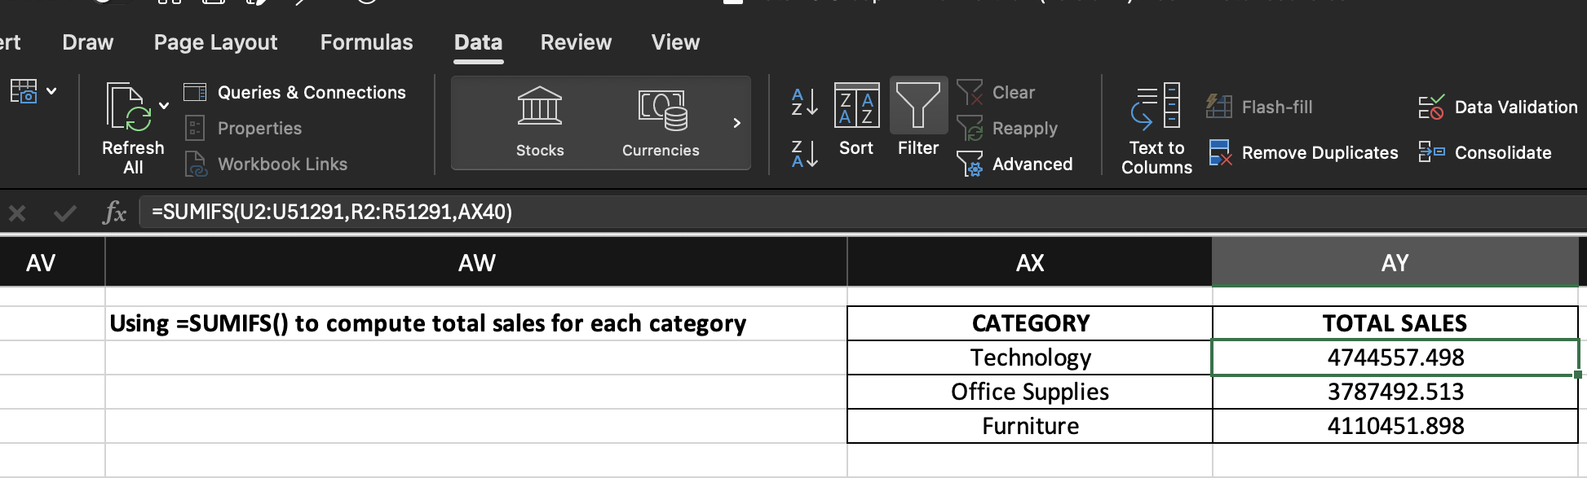

**To find the Total Sales for each category in one go, use:**

=SUMIFS(U2:U51291,R2:R51291,UNIQUE(R2:R51291)),

where UNIQUE() function is used to get the unique values across the column R (Category).

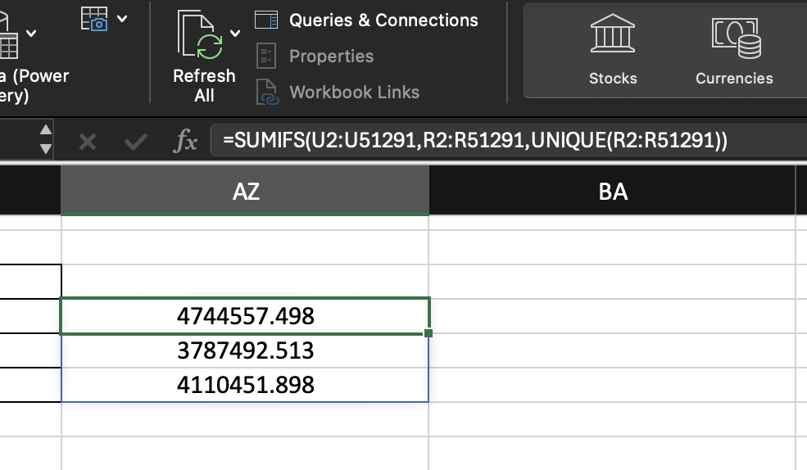

**22) Use =UNIQUE() to list all unique Segments in the dataset.**

**Ans.** Use the following function in formula bar:

=UNIQUE(J2:J51291)

, where J is the Segment column**.**

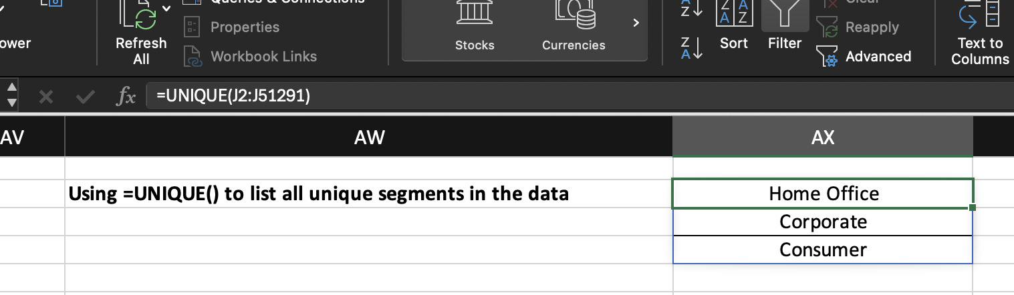

**23) Use =FILTER() to extract orders where Discount is greater than 0.2 and Sales exceed 15000.**

**Ans**. Use the following function in the formula bar:

=FILTER(A2:Z51291,(W2:W51291>0.2)*(U2:U51291)>15000,"NOT FOUND")

, where W is the Discount column, and U is the sales column. If no data is found, the filter function would return “NOT FOUND”.

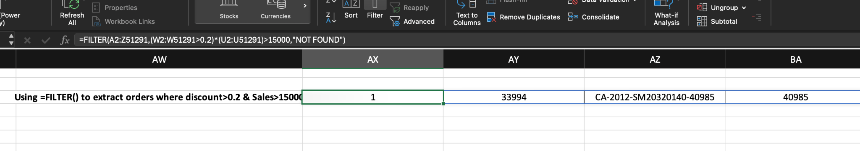

**TASK 3**

**CHARTS AND VISUALIZATION**

**1) What type of chart is best for comparing values across categories? (Hint: Think about bars and columns.)**

**Ans.** Bar or Column charts are best for comparing values across categories. A column chart uses vertical bars, while a bar chart uses horizontal bars.

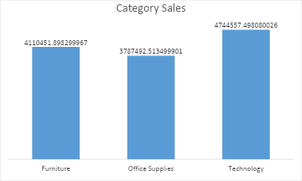

**2) How can you add labels to display data values directly on a chart? (Hint: Helps in**

**understanding exact values.)**

**Ans.**You can add data labels to a chart by selecting the chart, then going to the Chart Elements (+ button) → Data Labels. This will display exact values on the chart.

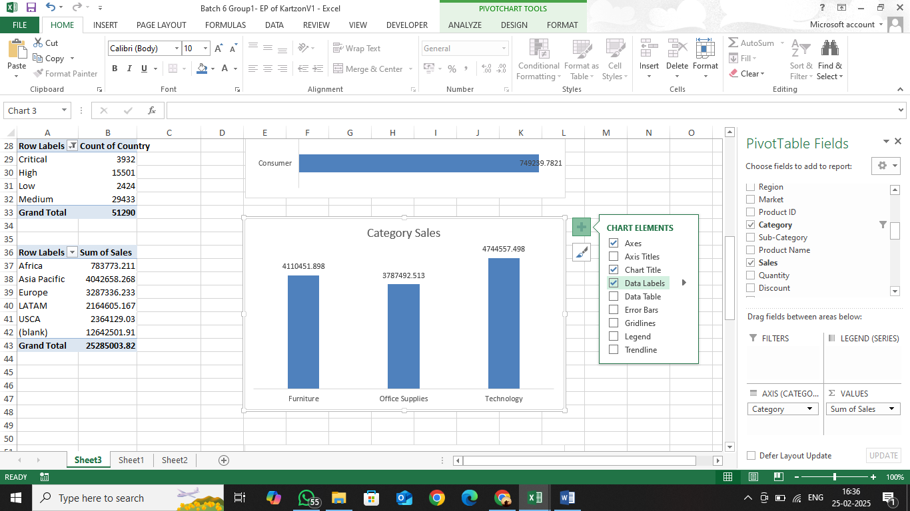

**3) Which advanced chart type is useful for showing data distribution over a range? (Hint: Common in statistics.)**

**Ans.** Box and Whisker chart is useful for showing the distribution of data over a range. It is commonly used in statistics to display median, quartiles, and outliers.

**4) What Excel feature allows you to create tiny charts inside a cell? (Hint: Used for trend visualization in a single cell.)**

**Ans.** Sparklines are tiny charts inside a single cell that help visualize trends. You can insert them by going to Insert → Sparklines and choosing Line, Column, or Win/Loss.

**PIVOT TABLES & PIVOT CHARTS**

**5) How can you quickly summarize large data sets in Excel? (Hint: Drag and drop fields into rows and columns.)**

**Ans.** We can do that using Pivot Tables by dragging and dropping fields into rows, columns, values, and filters. This helps organize and analyze data easily.

**6) What feature in Pivot Tables helps in breaking data into time-based groups? (Hint: Useful for handling date fields.)**

**Ans.** Grouping Feature allows to break data into time based groups. In a Pivot Table, we can group date fields (e.g., by days, months, quarters, or years) by right-clicking on a date column and selecting Group.

**7) What tool can be used to filter Pivot Tables interactively? (Hint: Visual filtering buttons.)**

**Ans.** Slicers are visual filter buttons that help us interactively filter data in a Pivot Table. You can add them by selecting your Pivot Table and going to Insert → Slicer.

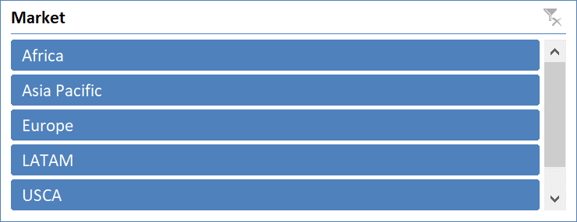

**8) What is the graphical representation of Pivot Tables? (Hint: Dynamic charts linked to summaries.)**

**Ans.** Pivot Charts are graphical representations of Pivot Tables. They update automatically when the Pivot Table changes and help visualize data in charts like bars, columns, or lines.

**DATA ANALYSIS TOOLS**

**9) Which feature helps you filter large datasets based on conditions? (Hint: Found in the Data tab, useful for narrowing down information.)  
Ans.** The Filter feature (found in the Data tab) helps us filter large datasets based on specific conditions. We can enable Filters by clicking on a column header and selecting Filter. This allows you to choose specific values or apply conditions (e.g., greater than, less than, or text filters).

**10) How can you calculate subtotal values within a dataset? (Hint: Inserts automatic grouping.)  
Ans.** The Subtotal feature (found in the Data tab) helps us calculate subtotal values within a dataset. It automatically groups data based on selected categories and applies functions like SUM, AVERAGE, or COUNT for quick calculations.

**11) What Excel tool allows you to find an input value based on a desired output? (Hint: Used for solving equations.)  
Ans.** Goal Seek allows us to find an input value needed to achieve a desired output. We can access it from Data → What-If Analysis → Goal Seek. It’s useful for solving equations, such as determining the sales required to reach a target profit.

**12) How can you create different possible outcomes of a scenario in Excel? (Hint: Useful for financial modeling.)**

**Ans.** Scenario Manager can be used to create and compare different possible outcomes in Excel. It is found under Data → What-If Analysis → Scenario Manager. It is useful for financial modeling as it allows us to test various input scenarios.

**13) What add-in helps in finding optimal solutions for complex problems? (Hint: Used for constraint-based optimization.)  
Ans.** Solver is an add-in used for finding optimal solutions to complex problems with multiple constraints. It is useful for constraint-based optimization, such as maximizing profit while minimizing costs. We can enable it from File → Options → Add-ins → Solver Add-in.

**ADVANCED EXCEL**

**14) What feature allows you to automate repetitive tasks in Excel? (Hint: Can be recorded or written using VBA.)  
Ans.** Macros allow us to automate repetitive tasks in Excel. WE can record them using Record Macro (under the Developer tab).

**15) What formula type works with multiple values at once? (Hint: Uses dynamic ranges, e.g., =SEQUENCE())  
Ans.** Array Formulas work with multiple values at once. Dynamic array functions, such as SEQUENCE(), FILTER(), and UNIQUE(), can return multiple values automatically.

**16) What function helps in fetching data dynamically from external sources? (Hint: Power-packed function for data transformation.)  
Ans.** Power Query (Get & Transform) helps in fetching and transforming data dynamically from external sources like databases, web pages, and other Excel files.

**17) Which tool in Excel helps in handling large datasets efficiently? (Hint: Used for advanced data modeling.)  
Ans**. Power Pivot helps in handling large datasets efficiently. It allows us to create data models, connect multiple tables, and perform advanced calculations using DAX (Data Analysis Expressions).

**18) How do you create an interactive dashboard combining multiple elements? (Hint: Uses charts, slicers, and Pivot Tables together.)  
Ans.** We can create an interactive dashboard by combining Pivot Tables, Pivot Charts, Slicers, and Conditional Formatting. This helps in visually analyzing and summarizing data dynamically.

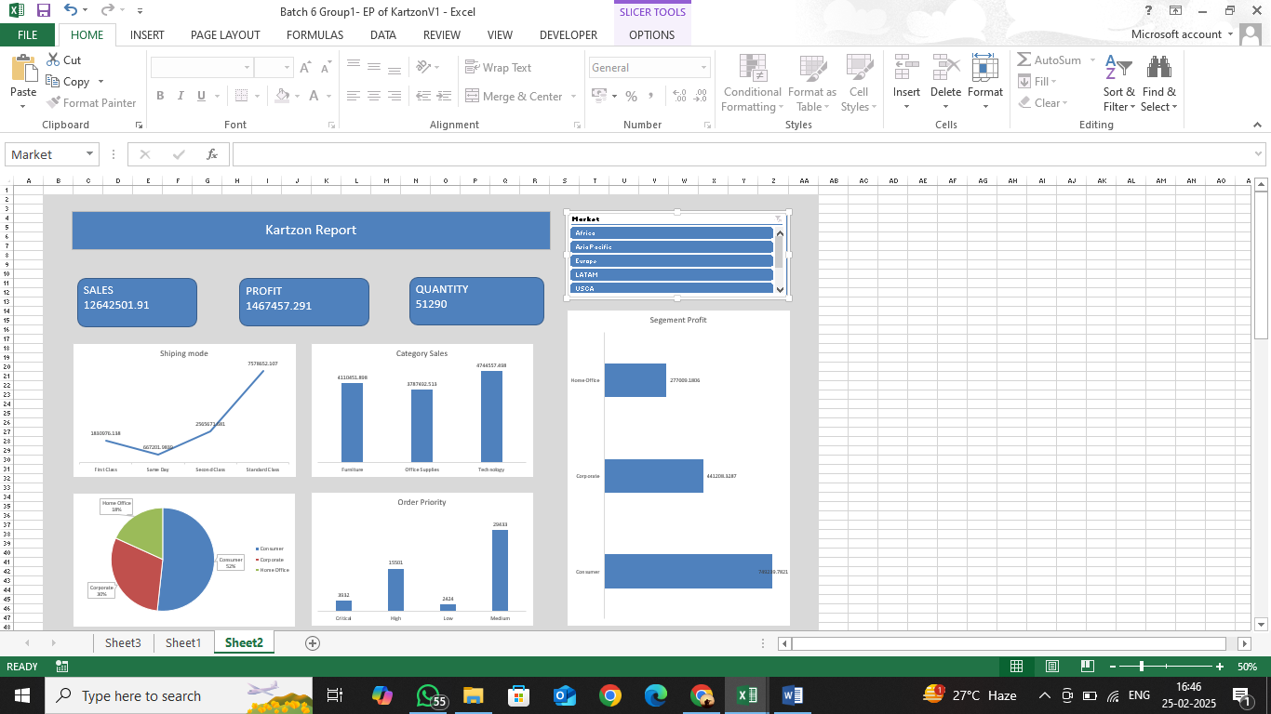

**COLLABORATION & SHARING**

**19) How can you restrict unauthorized edits in an Excel workbook? (Hint: Involves setting passwords.)**Ans. Protect Workbook/Worksheet – You can restrict unauthorized edits by setting a password using File → Info → Protect Workbook or Review → Protect Sheet. This prevents changes to specific sheets or the entire workbook.

**20) What feature allows multiple users to work on an Excel file simultaneously? (Hint: Available in cloud versions like Excel Online.)**Ans. Co-Authoring (Excel Online & OneDrive/SharePoint) – This feature allows multiple users to work on an Excel file simultaneously. It is available in Excel Online and cloud versions when the file is saved on OneDrive or SharePoint.

**21) How can you track modifications made to an Excel file? (Hint: Keeps a record of edits.)**Ans. Track Changes (Version History) – You can track modifications using Version History in Excel Online or OneDrive (File → Info → Version History).

**INTEGRATION & COMPATIBILITY**

**22) What are common file formats that Excel can import data from? (Hint: Includes text-based and web sources.)**Ans. Common File Formats that excel can import data from :

* CSV (.csv) – Comma-separated values (text-based)
* TXT (.txt) – Plain text files
* XML (.xml) – Structured data format
* JSON (.json) – Common for web and API data
* Access Database (.accdb, .mdb)
* SQL Server and other databases
* Web Data (from websites via Power Query)

**23) How can Excel connect to external databases like SQL or Power BI? (Hint: Used for live data integration.)**Ans. Excel can connect to external databases like SQL Server, Power BI, and others using Power Query (Get & Transform Data). We can find this under Data → Get Data → From Database to establish live data connections.

**24) What format should you use to save an Excel sheet as a shareable document without editing capabilities? (Hint: Commonly used for non-editable reports.)**Ans. To save an Excel sheet as a non-editable, shareable document, we can use the PDF format. We can do this by going to File → Save As → PDF or Export → Create PDF/XPS.